Biodiversity Pretest (High School)

Science is easier to understand if you can make connections between what you know now and the new ideas you are studying. This is a test that will help us know what you know now.

Please answer these questions as carefully and completely as you can. If you aren’t sure of the answer, please write any thoughts that you have. If you can help us to understand how you think about these questions, then we can do a better job of explaining science in ways that make sense to you.

Please put your initials (not your full name) in these boxes:
Also put your initials on the top of each page.
First Middle Last
Date _______________________

Class ______________________ Teacher ____________________________

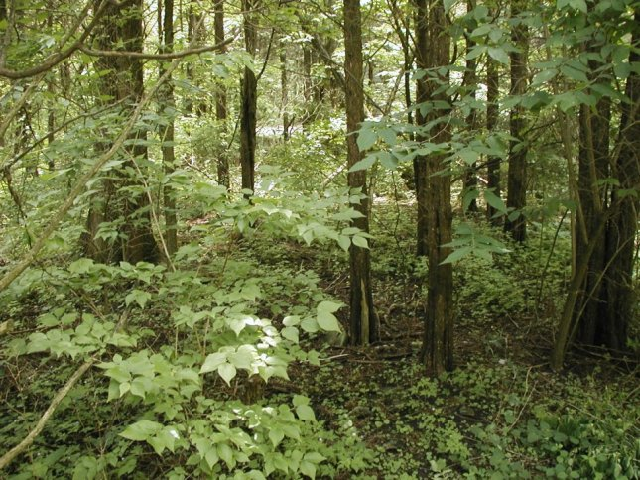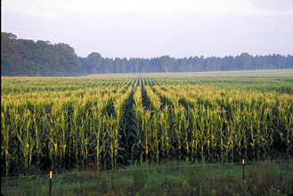

Forest Corn Field

1a. Above are pictures of a Michigan forest and a Michigan corn field. Explain why you think these places are similar and different:

Ways they are similar:

Ways they are different:

1b. Do you think more kinds of living things are living in the forest or in the cornfield?

Circle one: | Forest | Cornfield | The same in both

Explain why you think this:

1c. What differences do you think you would see in the soils of the corn field and the soils of the forest? An example is given for you

Difference | Forest soil | Corn field soil | Explanation
Type of plant material | Tree leaves, bark, twigs | Corn stems and leaves | When trees and plants die or leaves fall in a forest, they become part of the soil while dead corn plants become part of the soil in the corn field

1d. A farmer decided to cut down the forest, remove all of the tree stumps and plant corn, but the corn did not grow very well during the first year after cutting down the forest. Why do you think this might happen?

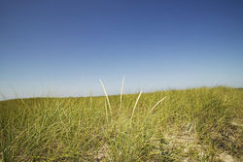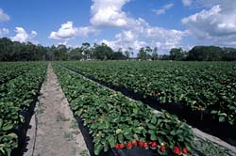

Wild Grassland Strawberry Field

2. A wild grassland is turned into a managed strawberry field. In the boxes below, describe what happened to the plant, animal and soil communities as a result of this transformation.

What happened to the plant community?

What happened to the animal community?

What happened to the soil community?

3. If a scientist wanted to measure the diversity of species in a given area, what types of data might she collect?

4. Put the following items in the boxes below, going from the smallest (on the left) to the largest (on the right). Be sure to include all the terms.

Population
Gene
Species
DNA
Ecosystem
Dog
Chromosome

Smallest Largest
atom |  |  |  |  |  |  |  | planet

5a. In the boxes below, describe the soil in your school lawn in as much detail as you can:

What is the soil made up of? Name as many things as you can.

Where did all the parts of the soil come from?

How deep is the soil?_____________
How does the soil change as you dig deeper?

5b. If you were to use a microscope to look at the soil in your school yard, what might it look like? Use the box to the right to draw what you might see, and be sure to label everything you draw.

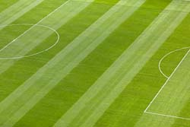

6. To the right is a picture of a soccer field. What would happen if people stop mowing and taking care of the soccer field? In the boxes below describe what the soccer field might look like, and all of the things that might be living there.

 | What might it look like? | What might be living there?
In 1 year
In 10 years
In 100 years

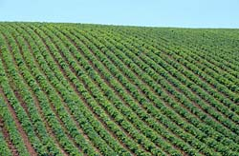
OR

6. To the right is a picture of a farmer’s field. What would happen if the farmer abandoned this field and no longer continued to care for it? In the boxes below describe what the field might look like, and all of the things that might be living there.

 | What might it look like? | What might be living there?
In 1 year
In 10 years
In 100 years
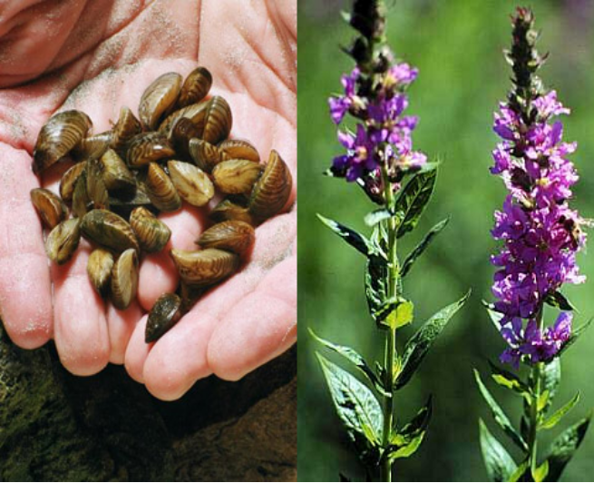
Zebra Mussels Purple Loosestrife

7. In Michigan, zebra mussels, and a plant called Purple Loosestrife have been introduced from different parts of the world. Their populations have rapidly expanded, and they are now taking up large areas of Michigan that were once home to other native species. We call species like zebra mussels and purple loosestrife “invasive species”.

a. Why do you think that these two species have done so well in their new environments?

b. Why do you think invasive species like these might be a problem in new ecosystems?

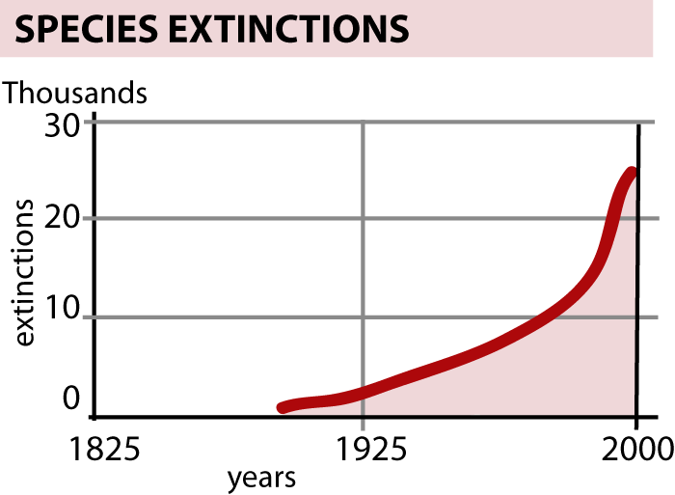
8. The graph to the right shows a rapid increase in the number of species going extinct over the last 100 years. Why do you think more species are going extinct each year?

In the boxes below, describe three possible reasons for the increase in species extinctions and decline in biodiversity.

Reason | How would this cause species to go extinct?
1.

2.

3.

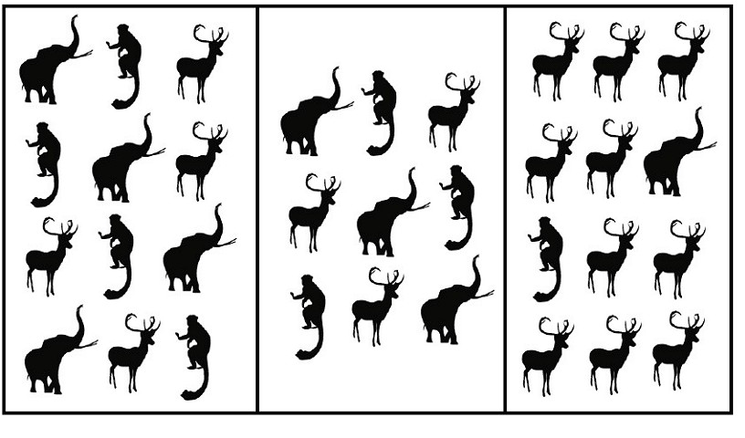
Ecosystem 1 Ecosystem 2 Ecosystem 3

9a. Do all of the three ecosystems shown above have the same species diversity?

Circle one: | Yes | No

Explain why you chose your answer:

9b. Many scientists say that it is important that we try to keep ecosystems as diverse as possible. Why do you think this is important?

